HK Profile: Frank Freeman - The Purest People photographer
Posted: 8 Apr 2015
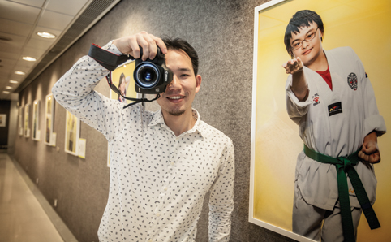
Imagine feeling so inspired by the people you work with that it changes who you are, right down to your name. That’s what happened to Frank Freeman – née Frank Chun. The professional photographer has just launched the third in a series of exhibitions in his biggest project to date, The Purest People. His portraits capture 23 sparkling personalities all aged between 10 and 20. But these aren’t typical models. In fact, they all have Down’s Syndrome – a genetic disorder caused by an extra chromosome that affects roughly 3,000 people in Hong Kong. The condition is typically associated with physical growth delays and intellectual disability, which can lead to prejudice against people with the disorder. That’s something Freeman wants to rectify through the power of photography. He’s found, from working with the models, that they highlight the importance of honesty and truthfulness, ultimately prompting him to change his name. “After shooting the models, I changed my name,” he says. “Now I’m Frank Freeman.”
The Purest People is a title inspired by a comment that Freeman’s English teacher made when he was at secondary school. “He said people with Down’s Syndrome are the purest people in the world,” explains Freeman. “They may have genetic differences to us but they have really pure hearts, innocent thoughts and are very good to other people.” Wind the clock forward six years and the story unfolds at City University, where the subject of Freeman’s final year photography project is Human Faces. “Instantly I thought of people with Down’s Syndrome,” he recalls. “When we’re walking in the streets, we can tell from their physical features that people have Down’s Syndrome but we don’t necessarily know much about it. My curiosity drove me to learn more.” The current exhibition in Quarry Bay is an extension of this graduate project. And it’s a project that Freeman has managed to put together on top of his full-time photography job with a local magazine. He’s worked tirelessly over the past year to co-ordinate models and makeup artists, arrange shoots and apply for sponsors to print the photographs (which cost a hefty $2,000 each).
Key to Freeman’s shots is the fact that the models are all doing, and wearing, exactly what they please. There’s keen swimmer, Betty, donning a costume and float, lined up next to Nathan – sporting full basketball regalia with a ball tucked under one arm. “The costumes that they’re wearing are what they love to do and what they’re good at,” says Freeman, “and the poses are a mutual thing. I’ll try a few pictures with one pose first, then we’ll look at the computer and talk about what works.” From the photos, it’s evident that Freeman is adept at putting people at ease, which he says is down to music. “People with Down’s Syndrome are very sensitive to sound,” he says. “I found out that Wing likes local singer, Eason Chan, so we played his songs during the shoot. My assistant and I started dancing together and she started laughing. I got this great picture with her lovely smile.”
The photographs all share a distinctive yellow background, which Freeman says reflects the happiness he’s felt over the past three years when working with his models. “Each of them presented their true character during the shoot and they opened up to me,” he says. “We shared a lot of happiness. It was tiring but it was the most enjoyable time in my shooting life.” He hopes that the photographs are valued by the subjects and their families, and is donating them to the models after the exhibition. “I think the photos help them to change the way they think of themselves a little,” says Freeman thoughtfully. “When you look in the mirror, you only see one side of yourself. You need another mirror, another person, to talk and give you different reflections. A picture can be a powerful visual reflection.”
As one of the first photography exhibitions in the city to focus on people with Down’s Syndrome, it has inevitably stirred up a lot of attention in the local press. Freeman hopes that it’s one of many projects to come that star people with Down’s Syndrome and help to improve understanding of the genetic disorder. “Some people think that those with Down’s Syndrome have low ability,” says Freeman, “but they have this bias without knowing them first. I wanted to do the exhibition so that people can see who they really are. Just by talking about the disorder, it’s a good beginning for change.” April Foster
The Purest People is on display at Lincoln House, Linkbridge, Taikoo Place, Quarry Bay, until Sunday April 12. Find out more at fungchan

